*Veja o mais recente Boletim da IAEA:*

In this edition of the *IAEA Bulletin,* readers will learn about the different areas of security where IAEA’s work is making a real difference. The progress made in a number of countries is highlighted, such as nuclear security measures as part of the fabric of Cuba’s modernization of its hospitals, Viet Nam’s investment in industrial radiography and Zimbabwe’s border control programme. Readers will also learn about Hungary’s experience in using nuclear forensics to support criminal prosecution, and about Indonesia’s experience in establishing a nuclear security culture methodology. Readers also have a chance to meet three young women who won the first IAEA essay competition on how to improve nuclear security worldwide.

IAEA Bulletin, December 2016, Vol. 54-7, ISSN:0020-6067, English

[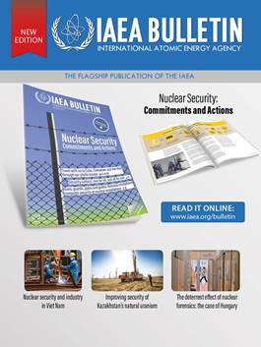](https://www.iaea.org/publications/magazines/bulletin/57-4)